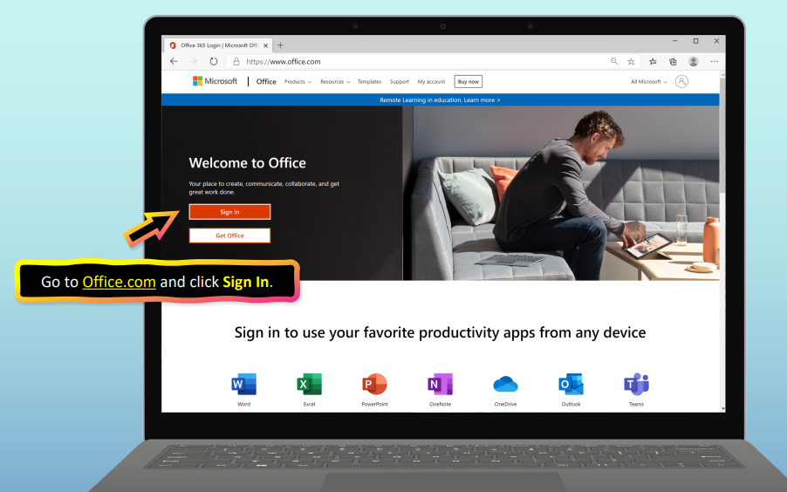

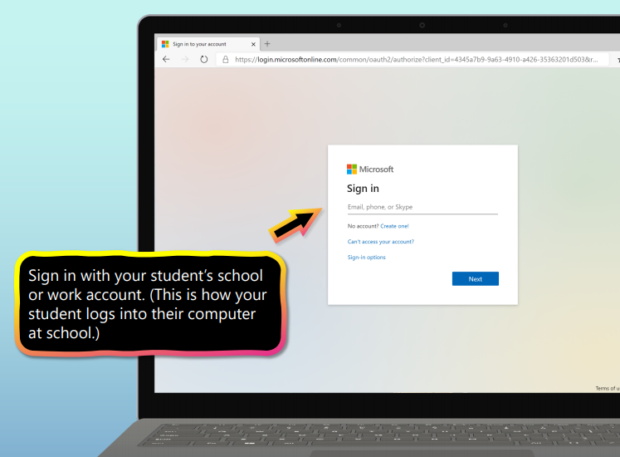
Go to office.com and sign in.
Your email address is your
username@nbss.nbed.nb.ca
It’s the first three letters of your
first name, the first three letters of
your last name and five numbers.
For example:
exampl12345@nbss.nbed.nb.ca

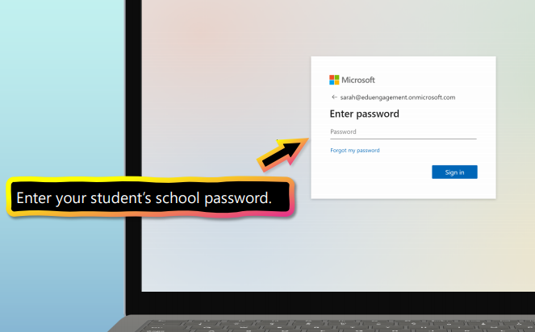

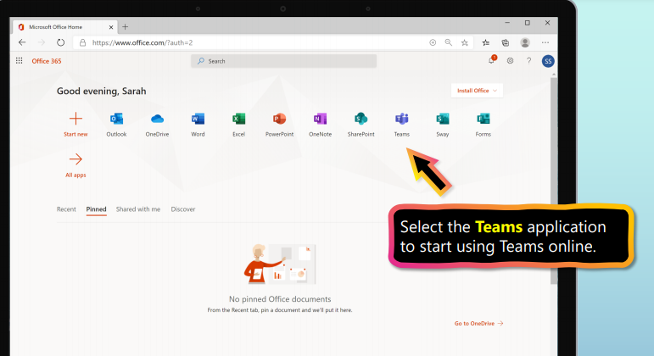
Student usernames & passwords were
sent home in student work packets.
If you’ve misplaced yours, contact
your teacher.
If you want to check your
email, choose Outlook.
If you want to sign in to
Microsoft Teams, it’s the
icon with the two purple
people.
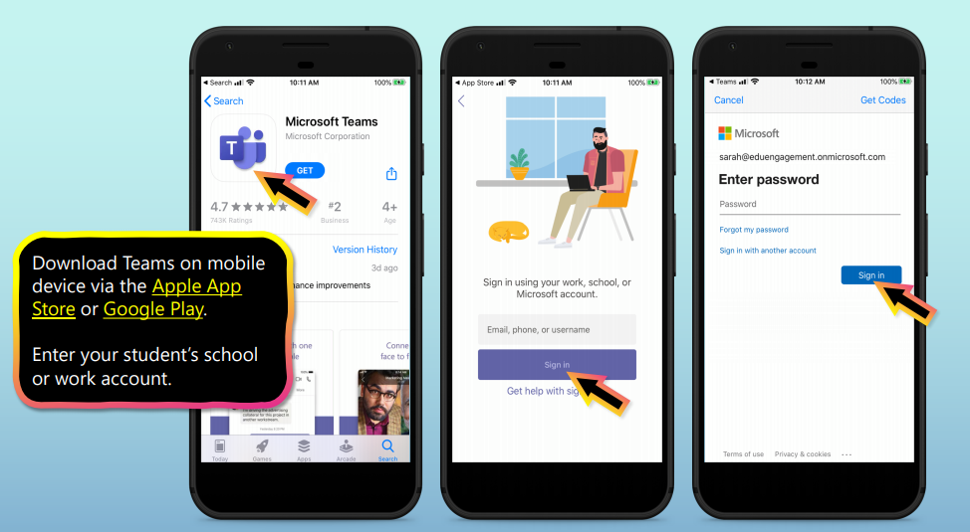
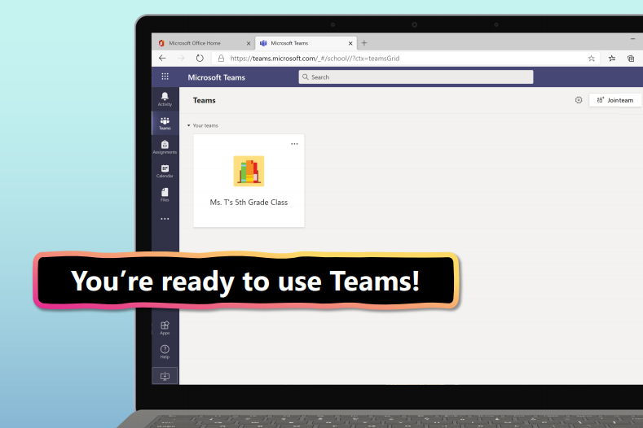
If you are using a mobile phone, you can download the Teams app and log in with your student account.

