Complete the Horses and Pigs rows.

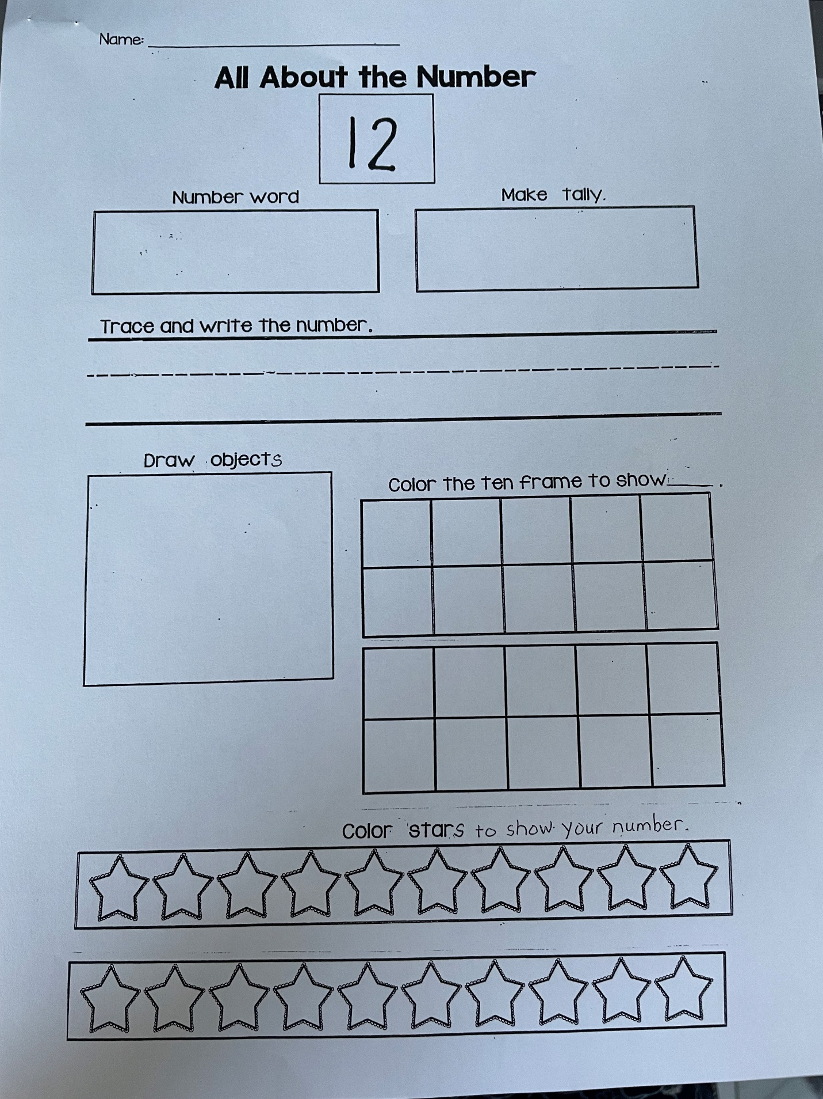

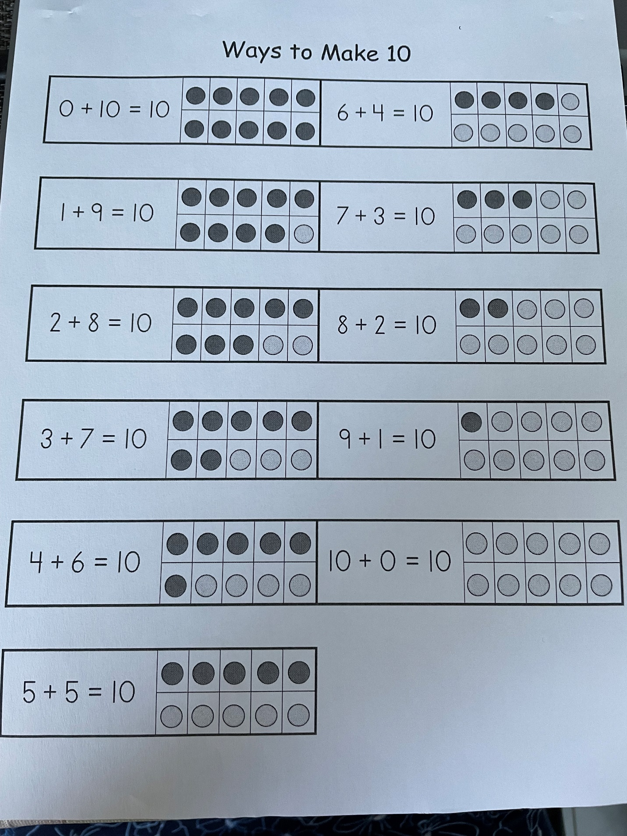

Spend 10-15 mins each day working on the mental Math activities below. Students should be able to do these quickly in their head, but please let them use the 1-100 number chart in their homework folder if they need it 🙂

1. Count by 2’s from **0-100** forwards and backwards, beginning and ending at different numbers (i.e. start at 48, count back by 2's to 32; Start at 86 count by 2's to 64)
2. Count by 5’s from 0-100, forwards and backwards, beginning and ending at different numbers (i.e. start at 15, count by 5’s to 40; start at 85, count back by 5’s to 25)
3. Count by 10’s from 0-100 forwards and backwards, beginning and ending at different numbers (i.e. start at 50 and count by 10's to 90; start at 100 and count back by 10's stopping at 40)
4. Count by 1’s forward and backward between any two given numbers from 1-100 (i.e. start at 68 and count to 90; start at 52 and count back to 43)
5. Identify **any** number on the Hundred Chart.  (point to any number on the 100 chart and have student say the name you point to.) Students should be able to do this quickly.
6. Call out any number between 0-100 and have student locate this number on the 100 chart.
7. Identify the number, up to 100, that is one more, two more, one less and two less than a given number. (i.e. what is 2 more than 49, what is 1 less than 89.) This should be easy and quick but if it's not, please use the hundred chart until they can do it without.
8. Identify the number, up to 100, that is **three more**, or **three less** than a given number. (i.e. what is 3 more than 49, what is 3 less than 89.)
9. Identify a number 10 more or 10 less than a given number (i.e. what is 10 more than 34, what is 10 less than 76)

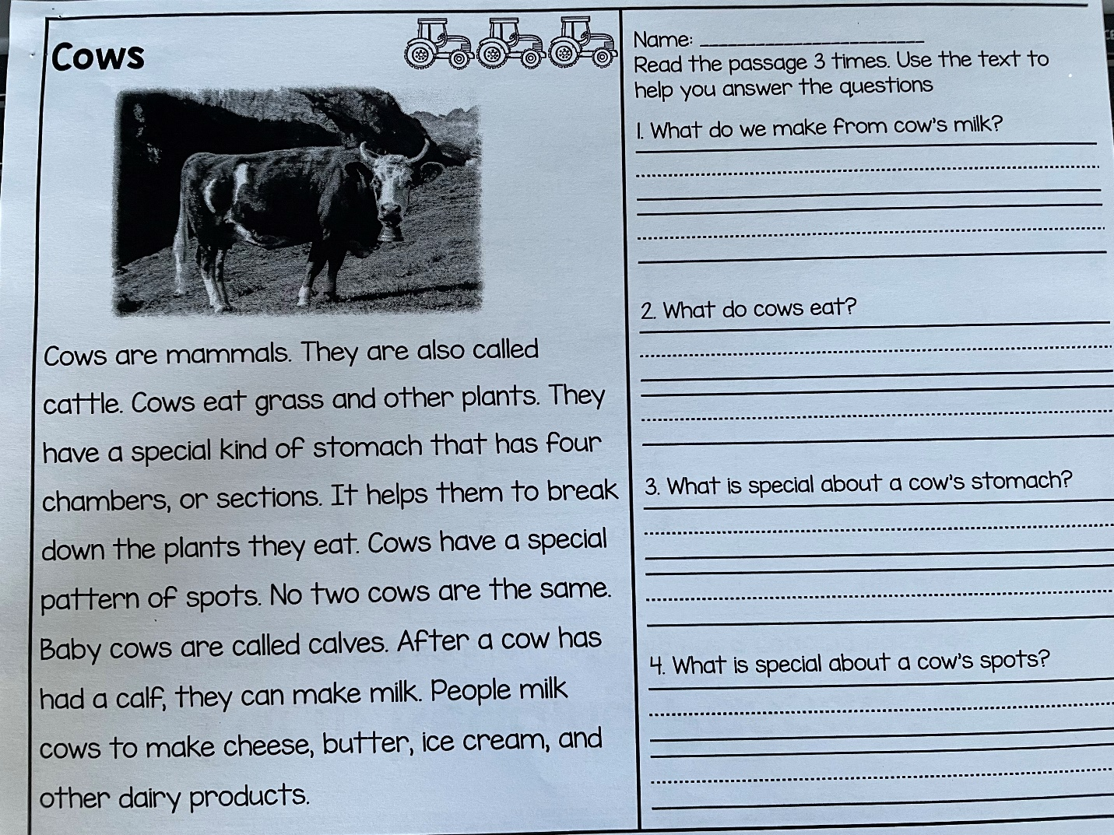

Writing - complete **Blankets or no blankets?** worksheet and write a letter to Farmer Brown with your reasons why the animals should or should not get blankets. (Both sheets are inside your packet).

****I am having issues uploading the above sheets.