Complete only one Reading Challenge a day.
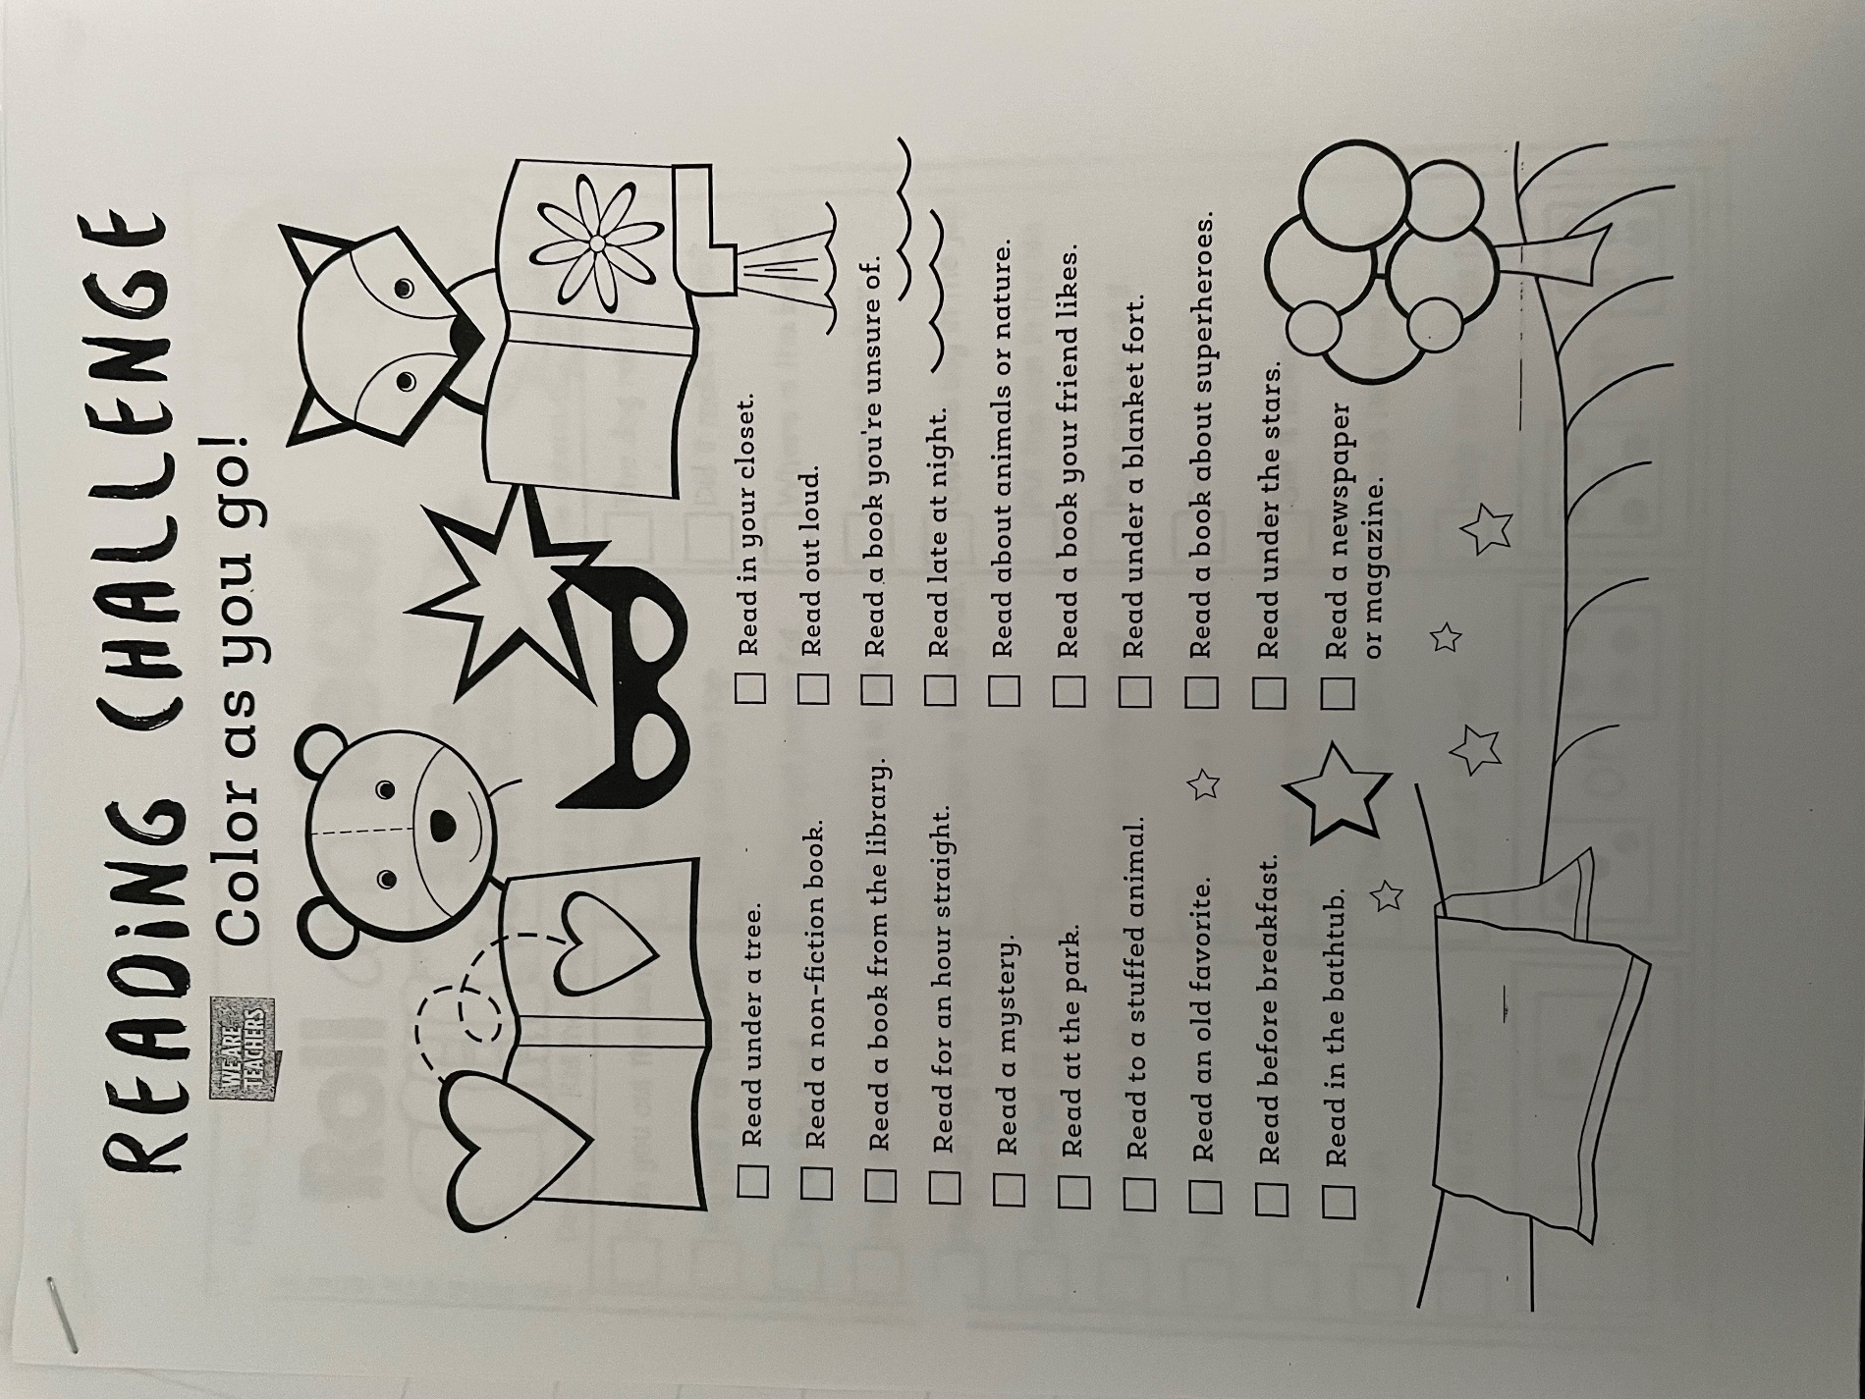

Listen to “Click, Clack, Moo” by Doreen Cronin on YouTube. Fill in the following details from the book.
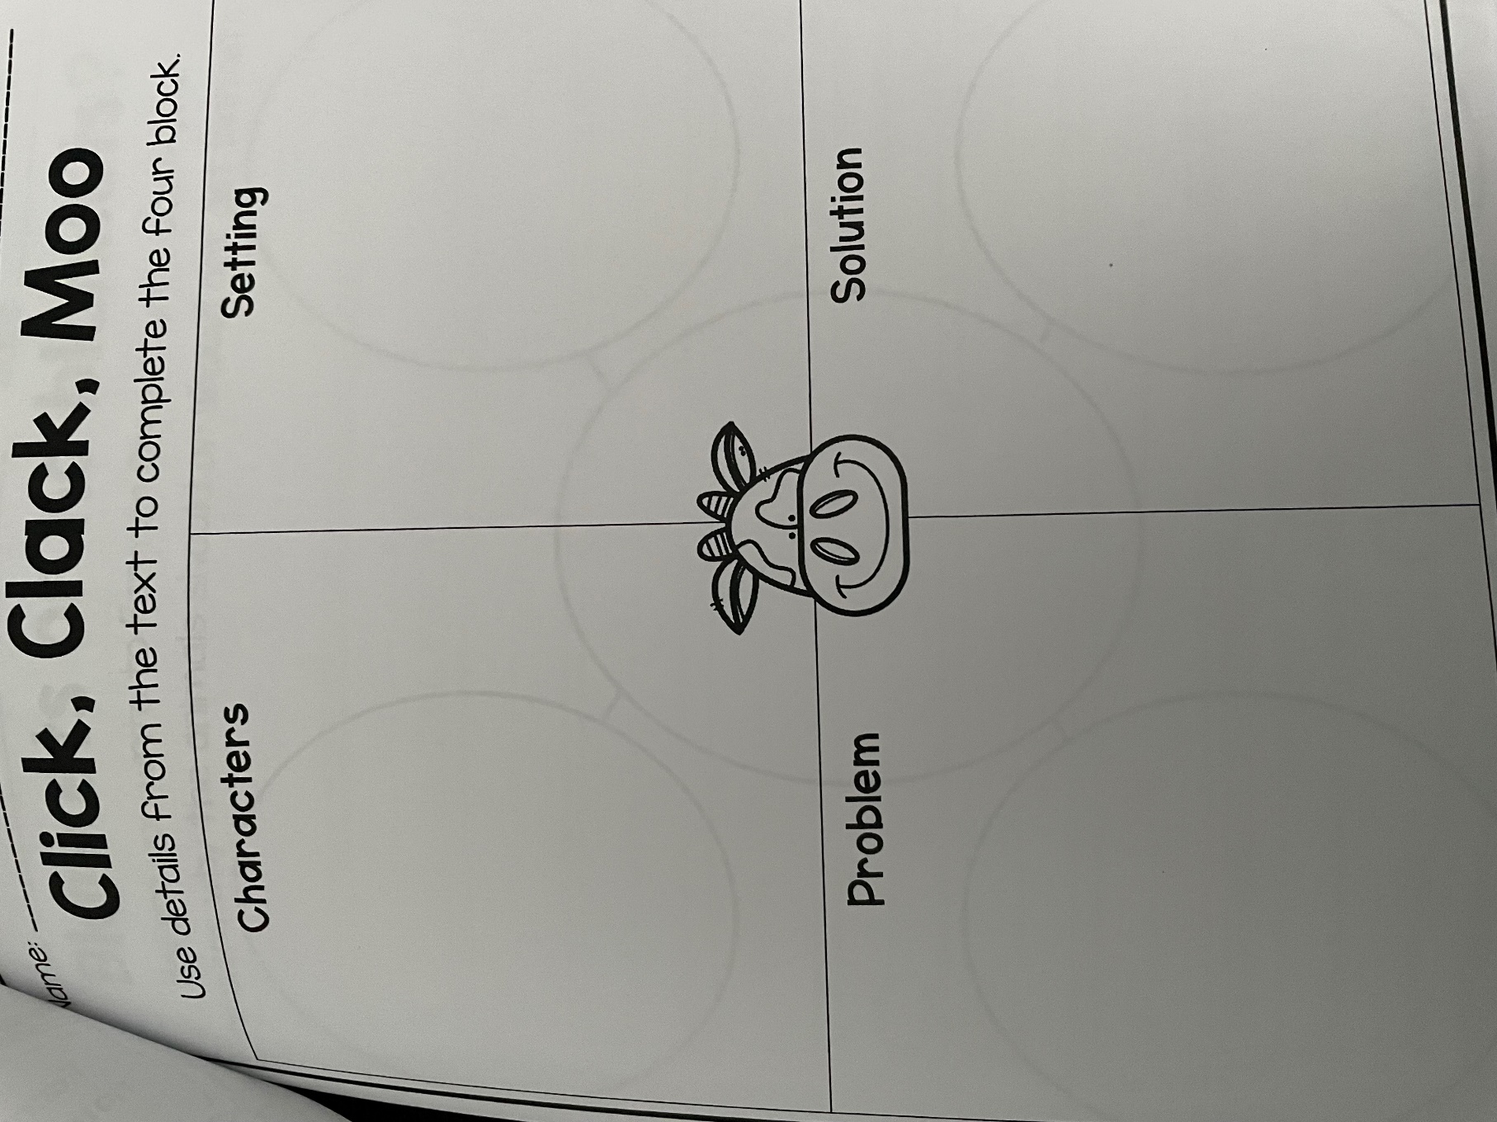
Using the provided number cards in your packet, cut out the cows and the goats to complete the first 2 rows.
