Personal Wellness Gr. 6/7
Nov. 8-11th
Home Learning

Day | Tasks
Each day | Each day you can do these short tasks, whether you have internet/device or not:  -Meditate for 5-10 minutes. You may like to listen to calming music while meditating: https://www.youtube.com/watch?v=Lju6h-C37hE  -Get physical! Go to the Max Aitken PE page OR do your own physical activity for 10 minutes (walk around, do some yoga, run on the spot/around your home. If you are able to, do some yoga using this video: https://www.youtube.com/watch?v=47Se2HWSv9k  Optional:  -Journal about your emotions for today, trying to be self-aware about what you may be feeling: anxiety, sadness, anger, joy, fear, bliss, etc.. Write at least one paragraph
Monday | *This lesson will likely need to be finished tomorrow!  -Virtual Teams meeting at 1:15. Go to your Teams calendar OR use this link: https://teams.microsoft.com/l/meetup-join/19%3ajHrd4MtF84L4RhLMTu5koCaLOs9xOyjgrK1-UAnhU2A1%40thread.tacv2/1636370338747?context=%7b%22Tid%22%3a%224d2b5fdf-c4d2-4911-8709-68cc2f465c9f%22%2c%22Oid%22%3a%2247be148a-44ca-4b0a-b8b7-208c2b5dad51%22%7d  -Write down ALL of what you have eaten today. Example:  Breakfast: scrambled eggs with ketchup, a piece of toast, a glass of milk  Lunch: 2 pizza pockets  Snacks: one granola bar, cranberry juice  -Write 3-5 sentences about if you think your choices where healthy and WHY.  -Go to this link: https://www.cspinet.org/eating-healthy/what-eat  -Take your time to read through the web page, clicking the links on the page to take you to the various articles  -Take a look at this “Take Action” https://www.cspinet.org/what-you-can-do/take-actions  -What can you do to take action?
Tuesday | -Watch this video to learn about how your nutrition affects your brain: https://ed.ted.com/lessons/how-the-food-you-eat-affects-your-brain-mia-nacamulli#watch  -Go through this lesson about how your nutrition affects your brain. Watch the video first, then click on the links to go to the other sections (see below):  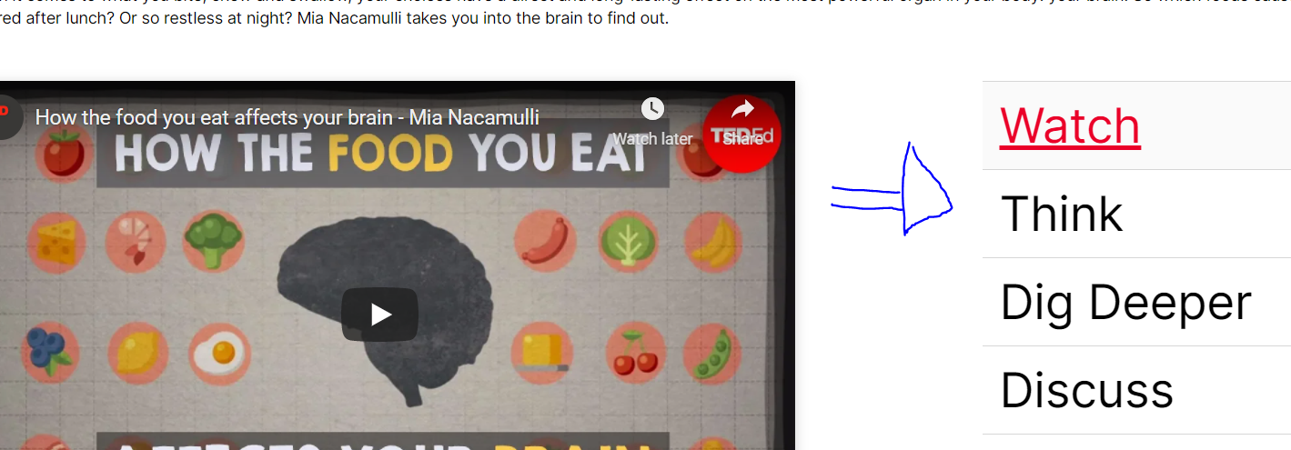
Wednesday | -Finish work from previous days  If you have time, go to:  - Go to myBlueprint: https://myblueprint.ca/  -Click login  -Scroll down until you see “school account login”:  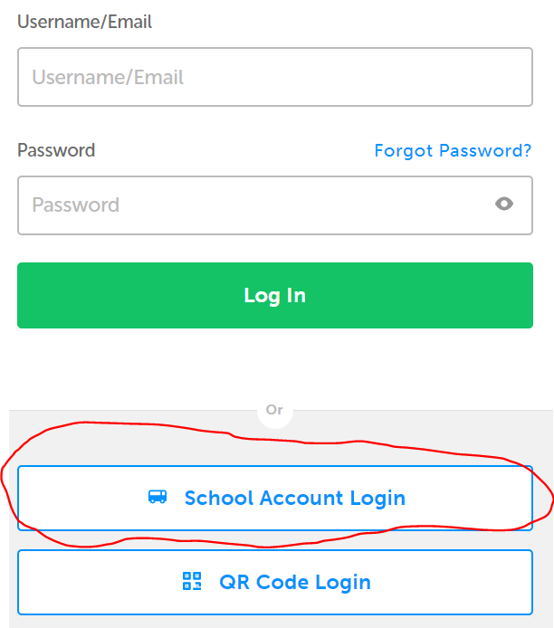  -Click on “ Anglophone North School Board”:  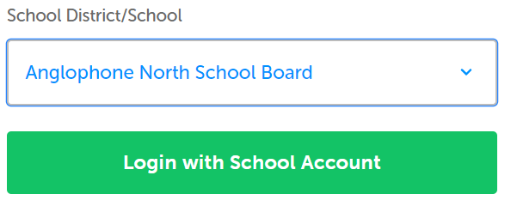  -Use your student email and password to login  -Once on myBlueprint, scroll down until you see the Who am I section and click on it:  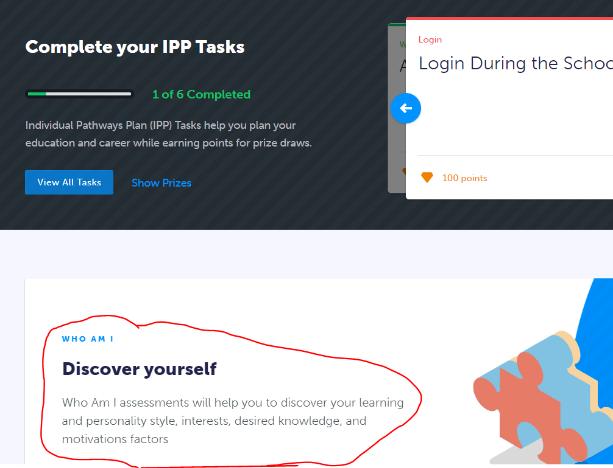  -Answer some of the Who am I surveys to learn more about yourself!
Thursday | Remembrance Day: No school
Friday | No Personal Wellness class on Fridays

