Math  Parents: Here is a website that generates just about any math worksheet that you would like:  https://www.math-drills.com/  Here are new links to a few:  *Grade 4: https://www.math-drills.com/multiplication/multiplication_vertical_050_0107_0107_001qp.1613579815.pdf  *Grade 5: https://www.math-drills.com/multiplication/multiplication_vertical_081_0210_0210_001qp.1613652222.pdf  __________________________________  https://www.multiplication.com/games/all-games  There are many fun games to try out on this site. I like the cannon ball game!  __________________________________  Here is a link to a new multiplication video. It explains multiplication and also gives you some tricks!  https://www.youtube.com/watch?v=dPksJHBZs4Q  __________________________________  * To be returned via email. |  | Home Learning  * There is no Teams meeting today as I have an appointment.  Hello folks,  Each day you will find your work here on my teacher site. If work is to be returned, please email it to: jeffrey.creamer@nbed.nb.ca  Miss you kiddos! See you MONDAY on Teams at 10:00! ~ M. Creamer |  | Here is a link to a website with many French cartoons:  https://www.dailymotion.com/search/cartoon%20francais/videos  Remenber, it is important to listen to as much French as possible each day. Check with your parents to make sure that it is ok for you to watch the episodes that you choose.
Give these a try. Use what you have learned about breaking one of the numbers apart and putting it back together after you multiply. If they are too tough, don’t worry, we will discuss them on Monday. Show me your work:
24 33 26 36
x 5 x 9 x 6 x 3
* Word Problem:
Vous pouvez acheter 1 pop-it pour 4$ ou acheter une offre pour 10 pop-its pour 35$. Combien économisez (save)-vous sur 10 pop-its si vous achetez l'offre ? Montre ton travail.
* To be returned via email.

M. Creamer’s Grade 4&5 French
November 9, 2021

Logic Time :  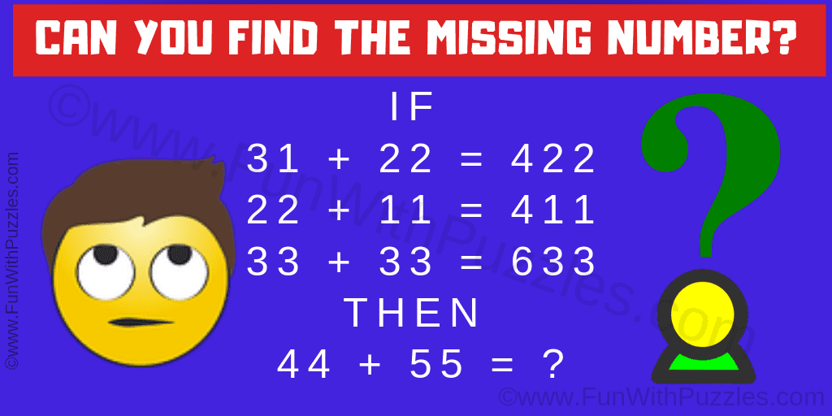 |  | Word Work  Here are your words for this week:  donne, dort, entre, être, faire, fait, famille, fille, frère, garçon  * Unscramble the words of the week:  1) ngaorç 2) iflel 3) ondne 4) trdo  5) rfiae 6) erêt 7) flaliem 8) afit  9) treen 10) ferrè  * Choose 2 different words than you did the last three days, and try to use them in the same sentence.  * To be returned via email.  We have been looking at exploration and explorers. Here is a video about the challenges of living and traveling in space:  https://www.esa.int/kids/en/Multimedia/Videos/Paxi_on_the_ISS/Living_in_space
Reading Each Day  You will find online libraries at:  Tumble Book Library  https://www.tumblebooklibrary.com/  The login info is:  Username: nblib Password: nbschools  Don’t forget about the ‘Je Lis’ library @:  https://jelis.rkpublishing.com/  Login info has been emailed to all.  There are English and French selections available. Students should read at least 20 minutes in French, and 10 Minutes in English each day.  * Please record what you have read each day by writing down: the title of the books you have read; the author’s name, and a short summary of what you have read about (in French).  * This can be returned via email at the end of the week. |  |  |  | French Writing  * You can choose today. Here are the options:  1) Where would you like to explore if you could go anywhere? Why?  Or  2) Tell me about a place that you have explored in your life.  * To be returned via email.  Activity  Don’t forget to get outside. Try to get 30 minutes of physical activity each day!  *Send me a picture and I will post it on my teacher site.

