Math  Here are a few websites that you can visit:  Practice place value:  https://www.mathplayground.com/place_value_party.html  __________________________________  Search for: ‘Adventure Man abcya’ on Google and click the first link, or look under my links for Adventure Man. Work on skip counting by 2’s, 3’s, and 4’s today on Adventure Man!  __________________________________  https://mrnussbaum.com/  Under the math tab, there are some good links to topics that we have looked at this year. You can check out:  Addition & Subtraction Practice:  https://mrnussbaum.com/drag-n-drop-math-online  Place Value…Place Value Pirates. Grade 4’s can give it a try up to 1000 and Grade 5’s can go to 10 000 (of course you grade 4’s can try 10 000 as well).  What math sentences can you think of for this picture:  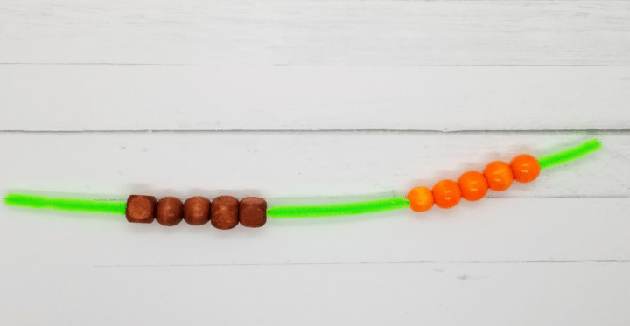 |  | Home Learning  Hello folks,  Each day you will find your work here on my teacher site. If work is to be returned, please email it to: jeffrey.creamer@nbed.nb.ca  Miss you kiddos!  - M. Creamer |  | Try this:  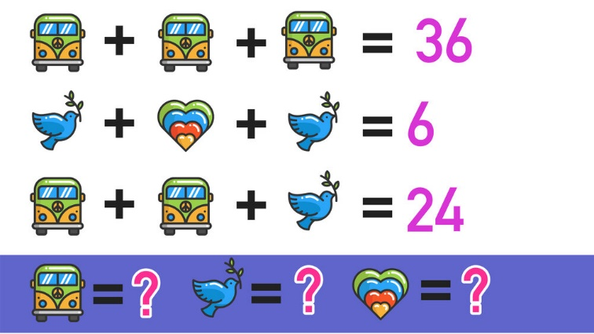
Copy these and complete each pattern:
 | 4 | 8 |  | 16 |  | 24 |  | 32

5 |  | 9 | 11 |  |  | 17 |  | 21

A | a |  | b | C |  |  | d | E
Yesterday’s answers (In red):
2 | 4 | 6 | 8 | 10 | 12 | 14 | 16 | 18 | 20
0 | 3 | 6 | 9 | 12 | 15 | 18 | 21 | 24 | 27
45 | 40 | 35 | 30 | 25 | 20 | 15 | 10 | 5 | 0

M. Creamer’s Grade 4&5 French
November 2, 2021

Word Work
Here are your words for this week (we had started them last week, but we did not get them wrapped up:
après, aussi, beaucoup, bonjour, chaque, chez, combien, comme, comment, devant
- Write your words with your opposite hand…good luck!
- Draw a picture and hide your words inside. Get someone to find your hidden words!
* To be returned via email.

Challenge:
Be kind to yourself today, you deserve it! Here is a mindfulness video to get you going:
https://www.youtube.com/watch?v=70j3xyu7OGw

Reading Each Day  You will find an online library at:  Tumble Book Library  https://www.tumblebooklibrary.com/  The login info is:  Username: nblib Password: nbschools  There are English and French selections available. Students should read at least 20 minutes in French, and 10 Minutes in English each day.  Please record what you have read each day by writing down: the title of the books you have read; the author’s name, and a short summary of what you have read about (in French). This can be returned via email at the end of the week. |  |  |  | Writing  Please write me a short description of your first day of home learning.  Here are some words/phrases you may want to use:  - à la maison ………..at home  - ma famille………...my family  - faire mon travail…doing my work  - c'était amusant…..it was fun  - sur l'ordinateur…..on the computer  - difficile……………difficult/hard  - facile……………...easy  * To be returned via email.  Activity  Don’t forget to get outside. Try to get 30 minutes of physical activity each day!

