Math  Here are a few websites that you can visit:  Practice place value:  https://www.mathplayground.com/place_value_party.html  __________________________________  https://mathsframe.co.uk/en/resources/resource/573  Have fun with multiplication, addition, subtracting and rounding with this gem! Birds vs. Robots!  __________________________________  https://mrnussbaum.com/  Under the math tab, there are some good links to topics that we have looked at this year. You can check out:  Addition & Subtraction Practice:  https://mrnussbaum.com/drag-n-drop-math-online  Place Value…Place Value Pirates. Grade 4’s can give it a try up to 1000 and Grade 5’s can go to 10 000 (of course you grade 4’s can try 10 000 as well).  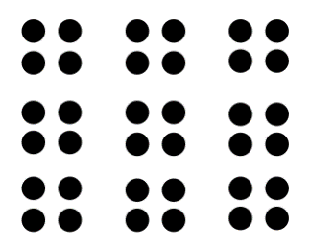  What math sentences can you think of for this picture:  Try to find  addition and  multiplication! |  | Home Learning  Hello folks,  Each day you will find your work here on my teacher site. If work is to be returned, please email it to: jeffrey.creamer@nbed.nb.ca  Miss you kiddos! See you on Teams at 10:00!  - M. Creamer |  | Try this:  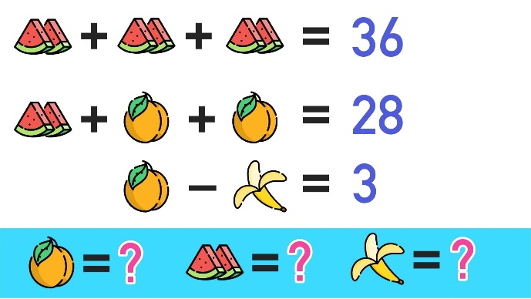
Copy these and complete each sequence:
25 |  | 33 | 37 |  | 45 | 49 | 53

100 |  | 150 | 175 |  | 225 |  |  | 300

200 | 180 |  |  | 120 | 100 |  | 60 |  | 20
Yesterday’s answers (In red):
0 | 4 | 8 | 12 | 16 | 20 | 24 | 28 | 32 | 36
5 | 7 | 9 | 11 | 13 | 15 | 17 | 19 | 21 | 23
A | a | B | b | C | c | D | d | E | e

M. Creamer’s Grade 4&5 French
November 3, 2021

 |  | Word Work  Here are your words for this week (we had started them last week, but we did not get them wrapped up:  après, aussi, beaucoup, bonjour, chaque, chez, combien, comme, comment, devant  - Get someone to quiz you on the words.  * Copy them in reverse, alphabetical order (Z to A).  * To be returned via email.  Challenge:  Be kind to your community today. Clean up some litter around your home (or clean your room if you can’t get outside). Check out this inspiring young man:  https://www.youtube.com/watch?v=IP-a0y7yH2o |  | “Somewhere, something incredible is waiting to be known.” – Carl Sagan
Reading Each Day  You will find an online library at:  Tumble Book Library  https://www.tumblebooklibrary.com/  The login info is:  Username: nblib Password: nbschools  There are English and French selections available. Students should read at least 20 minutes in French, and 10 Minutes in English each day.  Please record what you have read each day by writing down: the title of the books you have read; the author’s name, and a short summary of what you have read about (in French). This can be returned via email at the end of the week. |  |  |  | Writing  *Please write and tell me what you like more, dogs or cats. Give me two reasons for your choice.  PS: Dogs rule….lol!  * To be returned via email.  Activity  Don’t forget to get outside. Try to get 30 minutes of physical activity each day! Send me a picture and I will post it on my teacher site.

