Math  Parents: Here is a website that generates just about any math worksheet that you would like:  https://www.math-drills.com/  Under “Menu” you can choose what you wish to create. It would be great if the students could practice their basic multiplication facts!  __________________________________  https://mathsframe.co.uk/en/resources/resource/573  Have fun with multiplication, addition, subtracting and rounding with this gem! Birds vs. Robots!  __________________________________  https://mrnussbaum.com/  Under the math tab, there are some good links to topics that we have looked at this year. You can check out:  *Word Problems:  Spencer has 4 basketballs, Piper gives him 4 more. Jack, Payton, Rocco and Dallas all have the same number of basketballs as Spencer. How many basketballs do they have all together?  If Quincy has 456 apples (I know, why so many apples Quincy?), and Kallie takes 269 of them, how many does Quincy have left?  *Send me the answers with your work. |  | Home Learning  Hello folks,  Each day you will find your work here on my teacher site. If work is to be returned, please email it to: jeffrey.creamer@nbed.nb.ca  Miss you kiddos! See you on Teams at 10:00!  - M. Creamer |  | Try this:  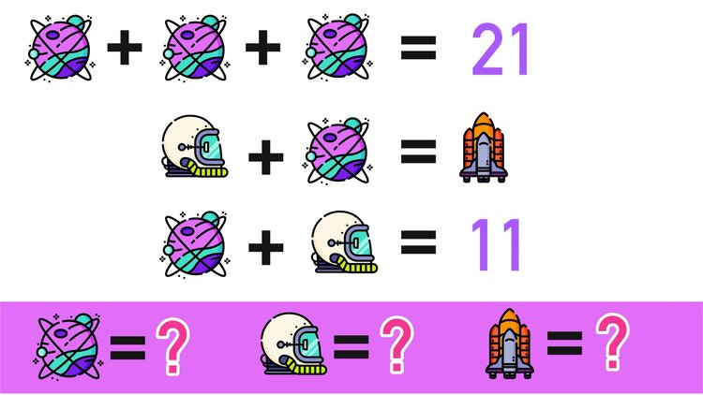
Copy these and complete each sequence:
8 |  | 24 | 32 | 40 |  |  | 64 | 72

500 |  |  | 350 |  |  | 200 |  | 100

12 |  |  | 42 |  |  |  | 82
Yesterday’s answers (In red):
25 |  | 33 | 37 |  | 45 | 49 | 53
100 |  | 150 | 175 |  | 225 |  |  | 300
200 | 180 |  |  | 120 | 100 |  | 60 |  | 20

M. Creamer’s Grade 4&5 French
November 3, 2021

 |  | Word Work  Here are your words for this week (we had started them last week, but we did not get them wrapped up:  * Find 5 French words in books you read today, that you do not understand and look them up in a dictionary. If you do not have a dictionary, look them up online. Write what they mean (in French).  * To be returned via email.  Exploration Video:  I found a good video about modern day explorers. Check it out!  https://www.youtube.com/watch?v=gJGS60c68HU |  | “Education is not preparation for life; education is life itself.” - John Dewey
 |  |  |  | 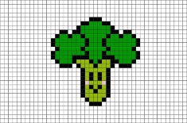
Reading Each Day  You will find online libraries at:  Tumble Book Library  https://www.tumblebooklibrary.com/  The login info is:  Username: nblib Password: nbschools  Don’t forget about the ‘Je Lis’ library @:  https://jelis.rkpublishing.com/  Login info has been emailed to all.  There are English and French selections available. Students should read at least 20 minutes in French, and 10 Minutes in English each day.  Please record what you have read each day by writing down: the title of the books you have read; the author’s name, and a short summary of what you have read about (in French). This can be returned via email at the end of the week. |  |  |  | Writing  * Write me if you like to eat broccoli or not. Explain why?  Some words or phrases you may want:  broccoli = le broccoli  it is delicious = c'est délicieux  it is disgusting = c'est dégoûtant  I like it alot = je l'aime beaucoup  I dislike = je n'aime pas  * To be returned via email.  Activity  Don’t forget to get outside. Try to get 30 minutes of physical activity each day! Send me a picture and I will post it on my teacher site.

