Math  Parents: Here is a website that generates just about any math worksheet that you would like:  https://www.math-drills.com/  Under “Menu” you can choose what you wish to create. It would be great if the students could practice their basic multiplication facts!  I have put some on our ‘Teams’. You will find them under ‘files’.  __________________________________  https://mathsframe.co.uk/en/resources/resource/573  Have fun with multiplication, addition, subtracting and rounding with this gem! Birds vs. Robots!  __________________________________  Here is a link to a multiplication video that you can watch:  https://www.youtube.com/watch?v=7-ryWoZ1UoI  __________________________________  * Math work:  Look under ‘Files’ on our Teams page. Select one multiplication sheet and complete it.  * Email me your answers. |  | Home Learning  Hello folks,  Each day you will find your work here on my teacher site. If work is to be returned, please email it to: jeffrey.creamer@nbed.nb.ca  Miss you kiddos! See you on Teams at 10:00!  - M. Creamer |  | Try this:  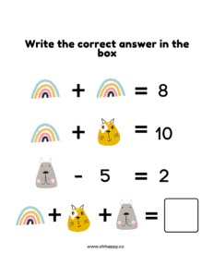This is from Conner. Thanks Conner!  Conner a $300, et Jack a $200. Combien ont-ils en tout?
* Copy and complete each question. Remember that you can break one of the numbers apart and put it back together after you multiply. Show me your work:
16 14 13 17
x 4 x 5 x 7 x 6
* Email these back to me.
Yesterday’s answers (In red):
2 | 11 | 20 | 29 | 38 | 47 | 56 | 65 | 74 | 83
1 | 4 | 7 | 10 | 13 | 16 | 19 | 22 | 25 | 28
64 | 66 | 68 | 70 | 72 | 74 | 76 | 78 | 80 | 82

M. Creamer’s Grade 4&5 French
November 9, 2021

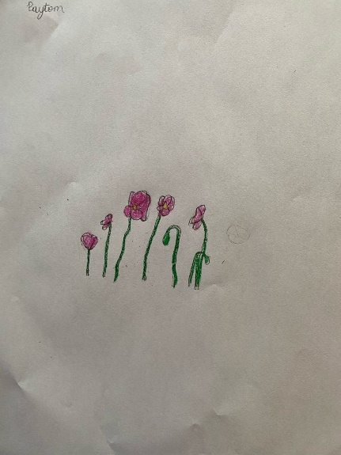  Here is a beautiful drawing of some Poppies from Payton:  Thanks  Payton! |  | Word Work  Here are your new words for this week:  donne, dort, entre, être, faire, fait, famille, fille, frère, garçon  We will discuss our new words on our Teams chat tomorrow.  * Please write your words in crossword form. Like we did many times in class.  * Please write your words in your most creative font. ‘Les beaux mots’  * Choose 2 different words than you did yesterday, and try to use them in the same sentence.  * To be returned via email.  We are looking at ways to be and to stay healthy. Here is a good video that explains what different items found in our foods do to help us be healthy:  https://www.youtube.com/watch?v=YimuIdEZSNY |  | 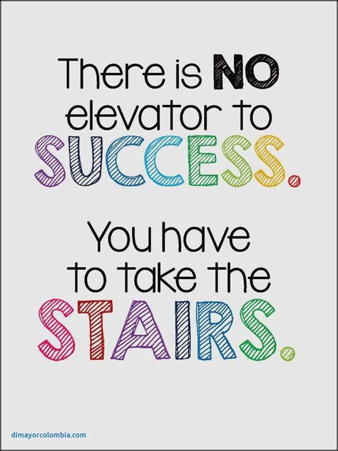
Reading Each Day  You will find online libraries at:  Tumble Book Library  https://www.tumblebooklibrary.com/  The login info is:  Username: nblib Password: nbschools  Don’t forget about the ‘Je Lis’ library @:  https://jelis.rkpublishing.com/  Login info has been emailed to all.  There are English and French selections available. Students should read at least 20 minutes in French, and 10 Minutes in English each day.  * Please record what you have read each day by writing down: the title of the books you have read; the author’s name, and a short summary of what you have read about (in French).  * This can be returned via email at the end of the week. |  |  |  | Writing  * Write to me and tell me what 3 healthy foods that you like to eat are. Why do you like them?  * To be returned via email.  There is a file on our Teams site called PNG image.png. If you open it, you will find a Remembrance Day activity that you can complete. Warning: You need a printer to complete this easily.  Activity  Don’t forget to get outside. Try to get 30 minutes of physical activity each day!  *Send me a picture and I will post it on my teacher site.

