Instructions for Logging into Teams

Using the Website:
-Go to office.com
-Login using student email and password (format for email: studentusername.nbss.nbed.nb.ca. Example for Cheryl Richardson may be: CHERIC12345@nbed.nbss.nb.ca)
-Typically, on the left side of the screen there will be icons. Click on the icon for “Teams”.

If using the app:
-Just login using your student email and password.
Once on Teams, click on the class you want to enter.
Example:
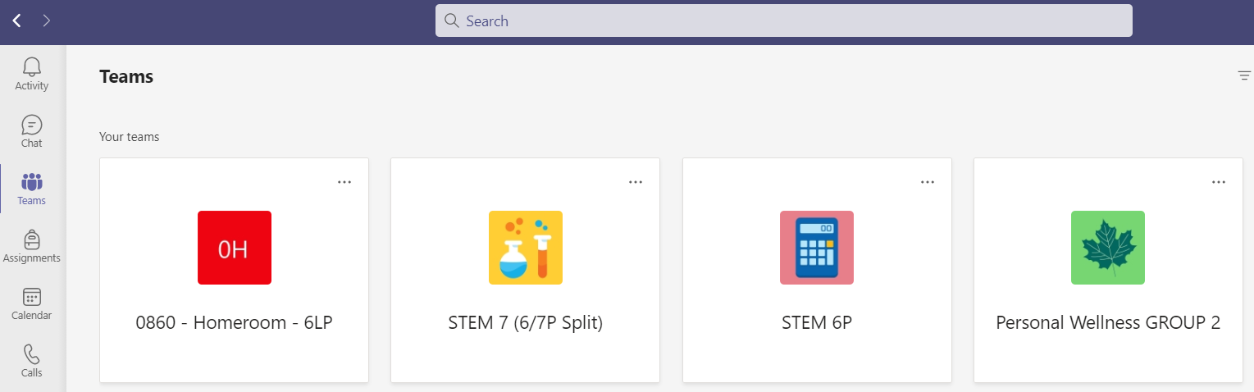

-Teams has a chat function where students can contact me:
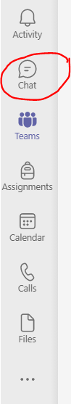

-Students can access their virtual meetings by using the calendar in Teams. The booked meeting will show up there and they just click on it to join.
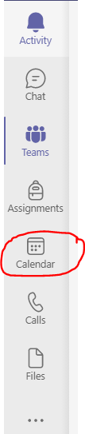

Email me if you have any issues!
Cheryl.richardson@nbed.nb.ca

