Name: ___________________ Date: ________________

Fill in the blanks:
Canada is a democracy. An MP is a Member of Parliament. An MP goes to Ottawa, Ontario to represent our area in the federal government. There are 338 electoral regions in Canada. Miramichi-Grand Lake is the name of our electoral region.
An MP will sit in the House of Commons in our capital city, Ottawa, ON. They are voted by the people in their constituency or riding. A riding or constituency is the name of the electoral region in which we live. Your MP will divide their time between Ottawa and Miramichi-Grand Lake. Canada’s Queen is Queen Elizabeth. The winner of the Miramichi-Grand Lake region is Jake Stewart. Canada’s prime minister is Justin Trudeau.

democracy 338 Miramichi-Grand Lake Ottawa
constituency Elizabeth riding Jake Stewart
Justin Trudeau

Match:
Conservatives Erin O’Toole Patti Deitch

Liberal Justin Trudeau Bruce Potter

New Democratic Party Jagmeet Singh Lisa Harris

Green Party Annemie Paul Jake Stewart

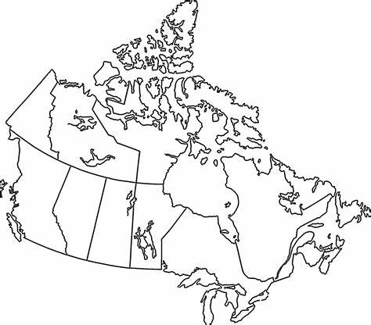

Colour New Brunswick on this map.

