Math  Here are a few websites that you can visit:  https://www.mathplayground.com/math-games.html  Search for: ‘Missing Digits’, there are some good addition and subtraction games.  __________________________________  Search for: ‘Adventure Man abcya’ on Google and click the first link, or look under my links for Adventure Man. Work on skip counting by 2’s, 3’s, and 4’s today on Adventure Man!  __________________________________  https://mrnussbaum.com/  Under the math tab, there are some good links to topics that we have looked at this year. You can check out:  Rounding…the basketball game is fun!  Place Value…Place Value Pirates. Grade 4’s can give it a try up to 1000 and Grade 5’s can go to 10 000 (of course you grade 4’s can try 10 000 as well).  What math sentences can you think of for this picture:  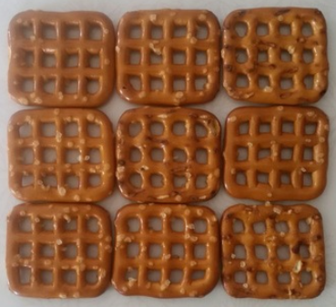 |  | Home Learning  Hello folks,  Each day you will find your work here on my teacher site. If work is to be returned, please email it to: jeffrey.creamer@nbed.nb.ca  Thank you all for your efforts!  - M. Creamer
Copy these and complete each pattern:

2 |  | 6 |  |  | 12 | 14

0 |  | 6 |  |  | 15 |  | 21

45 |  | 35 | 30 |  |  | 15 |  |  | 0

 |  |  |  | M. Creamer’s Grade 4&5 French

 |  | Word Work  Here are your words for this week (we had started them last week, but we did not get them wrapped up:  après, aussi, beaucoup, bonjour, chaque, chez, combien, comme, comment, devant  - Please write a sentence using each word.  - Please write each word in your most creative handwriting (Les beaux mots).  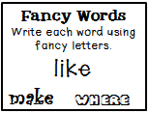  * To be returned via email.  Challenge:  Be a good community member and help someone else today. Here is a video to inspire you:  https://www.youtube.com/watch?v=OBbyjZdOsGo |  | A well-educated mind will always have more questions than answers.  ― Helen Keller
Reading Each Day  You will find an online library at:  Tumble Book Library  https://www.tumblebooklibrary.com/  The login info is:  Username: nblib Password: nbschools  There are English and French selections available. Students should read at least 20 minutes in French, and 10 Minutes in English each day.  Please record what you have read each day by writing down: the title of the books you have read; the author’s name, and a short summary of what you have read about (in French). This can be returned via email at the end of the week. |  |  |  | Writing  Please write me a short description (in French) about what you did on Halloween.  Here are some words you may want to use:  - les bonbons  - un costume  - un masque  - une citrouille  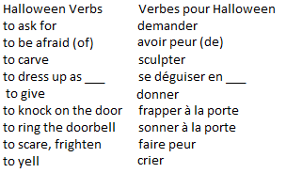 * To be returned via email.

