READING  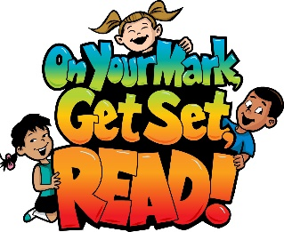 | Reading Websites: (Read/listen to books and retell the story to someone at home)  - Tumble Book Library  https://www.tumblebooklibrary.com/  Username: nblib Password: nbschools  - Story Line Online Library  https://storylineonline.net  *Keep a log of books listened to or read to share when we return. | 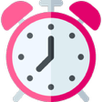  30 MINUTES
LITERACY - 30 MINUTES A DAY
WORD WORK  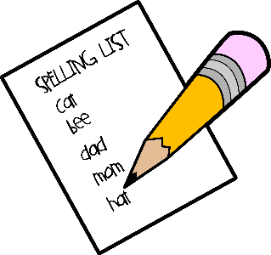 | Spelling list:  Word Work Suggestions:  - Spelling: Continue reviewing Unit 6 words. A new list will be uploaded later this week.  - Activities involving weekly Spelling list  - Rainbow write your Spelling words  - Use each of your Spelling words in a sentence  - Write Spelling words with a pen, pencil, marker  - Try writing your spelling words with your opposite hand.  - Test a parent or guardian on your words! | 10 - 15 MINUTES
WRITING  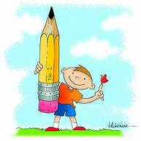 | Writing Suggestions:  - Letter Writing - write a letter to your teacher and email it if you can. (amy.anderson-mckay @nbed.nb.ca)  - Journal Writing – Daily journal ideas (PDF attached) | 10 - 15 MINUTES
MATH- 30 MINUTES A DAY
MATH  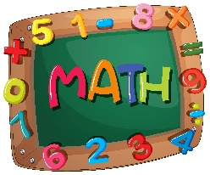 | Math Suggestions  - Dreambox (15-20 min)  https://play.dreambox.com/login/knjs/urus  **Please e-mail me for Username and Password  The first time a student logs on to a new device it might ask for the school code….for Max Aitken it is knjs/urus | 30 MINUTES
All evidence of student work in Literacy and Numeracy should be returned to school with your child when school resumes.
- You may want to keep a folder of all the work.
- You can log the reading daily.
- Keep a writing journal.
- Take pictures of learning happening. (Building, doing a puzzle, measuring for cooking or reading to a younger sibling.)

