Grade 8P2- Humanities ( Français et Science Humaine)
Covid- Response-At Home Learning Plan.
- My name is Cheryl Richardson and I teach French, Social Studies and Collaboration to your child, you may contact me at Cheryl.richardson@nbed.nb.ca in regards to any questions you may have. Please note, I work from 8:30-3:30 Monday-Friday and will get back to your child or you ASAP.

- Please check out my teacher page daily for any updates to home learning:
http://maa.nbed.nb.ca/teacher/mrs-richardson

- Your child has received their username and password to access their school e-mail and our TEAMS SITE (Office 365). On my teacher page I will direct students to either complete work or go to our TEAMS Site.

- Your child should be completing 45 minutes of French 3 days. This can be done at any time it is convenient for them (however, they must attend the scheduled TEAMS meeting at their designated time **** Please see schedule).

- In this packet you will find:

- 1 BOOKLET “Les vêtements”: We are starting a new unit
- 3 reading comprehension:
- “L’heure du coucher” Texte Narratif
- “Faire un gâteau” Texte Narratif
- “Dans le jardin” : Texte Narratif
- 2 Crossword puzzles: Les vêtements et accessoires.
- 1 copie of ALT codes for typing French characters
- 1 schedule of their TEAMS meetings.
- 1 poster “ Etiquette to follow during a Teams meeting”
6. During our TEAMS meeting, I will be teaching and explaining the important concepts for the assignments which need to be worked on for the week. Its very important students attend their scheduled meeting to receive explanations and ask questions. This is also where attendance will be taken. I would also recommend students to not complete work which has not been assigned yet or explained.
7. Monday-Thursday I have several virtual meetings scheduled; I will do my best to answer questions outside of our TEAMS meeting time. On Fridays, I have dedicated this day to answer questions and meet one on one (virtually) with students who need extra help.

Stay safe, happy, and healthy: Ms. Richardson

8P2 Schedules
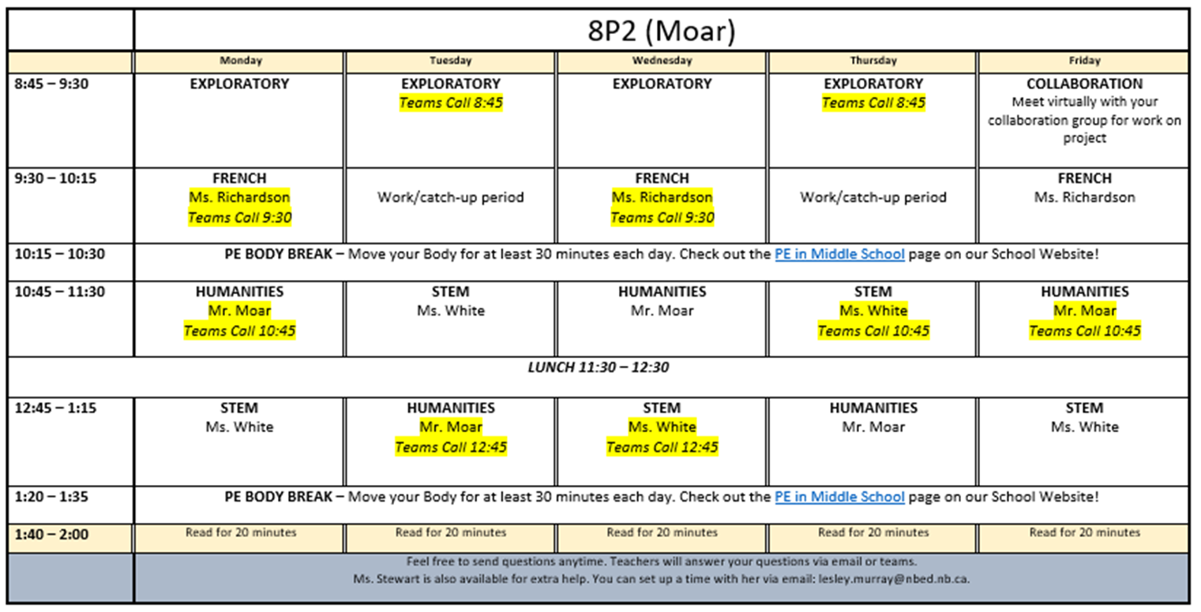

Etiquette (procedures)
Virtual Meetings
