October 25, 2022

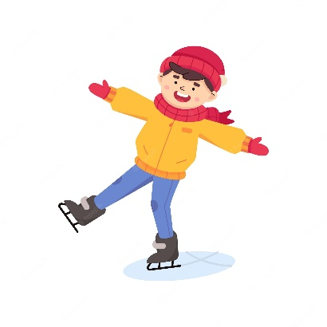
Skating Schedule changes for 7/8 team
Here is the UPDATED schedule for skating until end of December 2022.
Date | Time | Class
Thursday November 3rd | 9:30-10:30 | 8P & 8E
Thursday November 17th | 9:30-10:30 | 7/8E & 7/8P
Thursday December 1st | 9:30-10:30 | 7P & 8P
Thursday December 15th | 9:30-10:30 | 7/8E & 8E & 7/8P

Students require helmet, skates, gloves, and warm clothes to participate. The school has many sets of skates in all sizes for those who do not have any, and we have some helmets too. Please be prepared to skate on these days as it is part of the Phys. Ed curriculum. Ask your teacher for equipment in advance, students who are not skating will remain at school.

October 25, 2022

Skating Schedule changes for 7/8 team
Here is the UPDATED schedule for skating until end of December 2022.
Date | Time | Class
Thursday November 3rd | 9:30-10:30 | 8P & 8E
Thursday November 17th | 9:30-10:30 | 7/8E & 7/8P
Thursday December 1st | 9:30-10:30 | 7P & 8P
Thursday December 15th | 9:30-10:30 | 7/8E & 8E & 7/8P

Students require helmet, skates, gloves, and warm clothes to participate. The school has many sets of skates in all sizes for those who do not have any, and we have some helmets too. Please be prepared to skate on these days as it is part of the Phys. Ed curriculum. Ask your teacher for equipment in advance, students who are not skating will remain at school.

