Let’s be real. Most of your time at home is being spent “checking school emails/on TEAMs”, aka scrolling through Instagram and other on-line sites while laying on the couch. But if you have one extra ounce of ‘get up and go’, get up and go try these 5 exercises the next time you’re scrolling on your phone (and tell everyone to leave you to it because you have “so much work to do!”)
Plank Jacks: Start
Plank Jacks: Middle
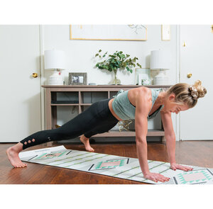
Plank Jacks: End
Glute Bridge: 30 Second Hold
Reverse Glute Bridge: Start
Reverse Glute Bridge: End
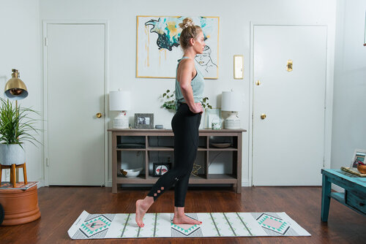
Kick Backs: Start
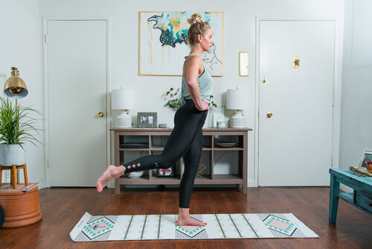
Kick Backs: End
Have a good day!

