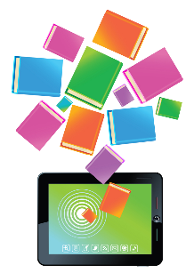
Check out SORA!
- Access 9,000 FREE eBooks and audiobooks
- Open 24/7 and accessible from school or home
- Customize your child’s reading experience

Dear Parents/Guardians,

Max Aitken Academy is pleased to inform you that all students now have access to free ebooks and audiobooks through SORA.
SORA is a provincial eLibrary created by the Department of Education and Early Childhood Development which provides students, parents (via their child’s school username and password), and staff in Anglophone schools with access to a wide range of eBooks, audiobooks, and read-alongs, which will appeal to a variety of student interests and reading levels.
The collection includes a mix of fiction, nonfiction, French language books, and culturally- inclusive books, including those with Indigenous content. Books are also chosen to ensure a range of representation for inclusive environments: LGBTQ2SI, neurodiversity, and family context.
Books can be checked in and out-- both inside and outside of school--on school devices as well as personal devices. The app not only provides access to reading material – by checking out the ebook and audiobook version of a title, students can listen to a professionally narrated book and follow along with the text. Students can also use built-in tools like bookmarks,dictionary, highlights and notes. They can also personalize the font (including the dyslexia font), font size, text weight, page background/font colour and line spacing.
For step-by-step directions for accessing SORA, please read the attached user-guide, which also includes your child’s username and password. We will also be sharing information on our school website and social media platforms. If you have any questions please do not hesitate to reach out to your child’s teacher or Ms. Campbell (jayme.campbell@nbed.nb.ca).

Happy Reading!

Jayme Campbell
Vice-Principal
Max Aitken Academy

