MAA Young Entrepreneurs
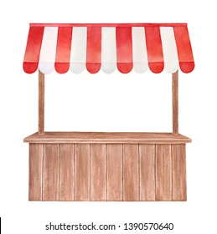
Wednesday, June 1st, 2022
Your Money
Your Name/Product: _____________________________________________________
Float (Do NOT spend this money! Keep your personal spending $ separate.): $ _________
Loan: $ _________
Price of product(s): $ ______________________________
How many products I have at the beginning: # _________
Tally of products sold: | Tips ($):
Total money count at the end: $_______
-$_______(float)
- $_______(loan)
- $_______(tips)
=$_______ (profit)
10% of profit to charity: $________
$_______(profit) – $_______($ for charity) = $_______(TOTAL PROFIT) TEACHER SIGNATURE: ___

