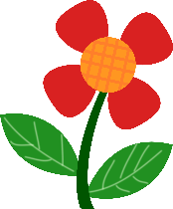This week’s reminders:   
- Reading log (read 3-4 times this week)  
- Earth day Today! (April 22nd) Be extra kind to the Earth!

Calcul mental :   
(should be able to do it easily in your head, but I want you to show the steps your head did.)  
a) 58 + 22 = ____ b) 40 – 12 = ____

c) 125 – 50 = ____ d) 15 + 25 = ____

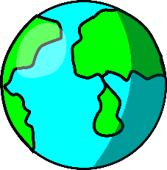

[This Photo](https://educomagia.blogspot.com/2016/11/las-capas-de-la-tierra.html) by Unknown Author is licensed under [CC BY-SA-NC](https://creativecommons.org/licenses/by-nc-sa/3.0/)

**Math** :

Due Friday

**Révision des sons & des mots**

**ui & tion**

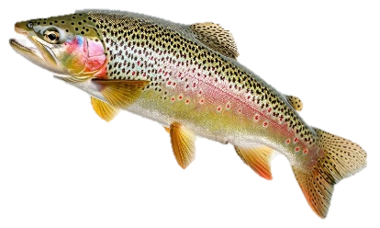

page (nf) puis (adv)

bébé (nm) alors (adv)

vite (adj/adv) lui (pron)

toi (pron) bas (adj)  
 fille (nf) nos (adj. poss)

*\*test vendredi (Friday)*

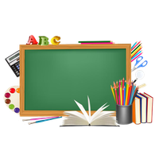

**Mme   
Comeau**

Tracy.lhuillier@nbed.nb.ca

**Corrigé les phrases suivantes:**

jai de grand chiens bruns et blancs ______________________________________________________________________________________________________________________________________ Il y a sink personnes dans mon family et UnPoisson auçi. ______________________________________________________________________________________________________________________________________