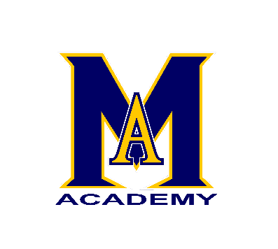

Date: March 29, 2017
Memo: Max Aitken Academy Parents
From: Mark Donovan, Principal
Re: Upcoming Events @ M.A.A.
- As part of our ongoing School Improvement Plan and focus on cultural awareness, Max Aitken Academy will celebrate Acadian Heritage with an Acadian Day this Thursday, March 30. Through special provincial funding we are able to offer students a day filled with both educational and fun events.
The day will include an Art Richard concert in the morning for all grade levels as well as a free sample of Acadian Chicken Fricot served in the cafeteria at noon and cookie. This will not be a full meal and our regular menu will still be available.
Students are also encouraged to participate in our noon hour contests; best Acadian costume (red, white and blue) and best Acadian dancers.
- Friday is a holiday for students as parent- teacher meetings will be held both Thursday evening (4:30- 7:00) and Friday morning (9:00- 11:30). Teachers will have meetings on Friday afternoon.
Elementary teachers have sent home appointment times, however, if you’d like to book an appointment but have not yet done so, please contact the school at your earliest convenience.
Middle school parents are invited to attend parent-teacher interviews which will be held in the cafeteria. This will be on a first-come, first-served basis on both Thursday evening and Friday morning.
***over***
- Fundraising Campaigns are now in full swing and we greatly appreciate your support in all of these endeavors. Grade 8 students are currently having a fundraiser to pay for their Ottawa trip and you are invited to view their frozen food catalogue and place an order for everything from main course items to dessert. All orders must be in by next Tuesday for this campaign.
The H&S Easter Dinner Campaign is wrapping up and if you have any tickets or money, please send them in by next Friday.
M.A.A. Clothing orders will be in by Easter and H&S will be selling various items during parent-teacher meetings, in the student council room.
- Class Pictures will be on sale for the rest of this week and next week. Pictures are
$ 3.00 each.

Middle Level students will be selling pics at the 2:00 and 3:00 dismissal times for parents and during noon hour for students.

End

