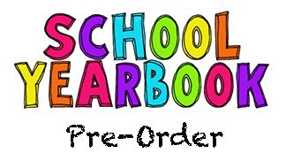

January 11, 2021
MEMO: Yearbook 2020-21

Dear parent/guardian:
Max Aitken Academy is once again offering a school yearbook that can be purchased by
K-8 students. The cost of the yearbook is $25.00. Yearbooks are expected to arrive in early June.
All grade levels will appear in the yearbook (class pictures and individual student photos). Students that are involved in activities, sports and special events at school are likely to appear more often.
If you are interested in purchasing a yearbook for your child, please complete the order form below and send the money and form to your child’s homeroom teacher. Payments can be made in cash or by cheque (payable to Max Aitken Academy).
All orders must be placed before March 12, 2021.
Thank you for your support!
Max Aitken Yearbook Committee
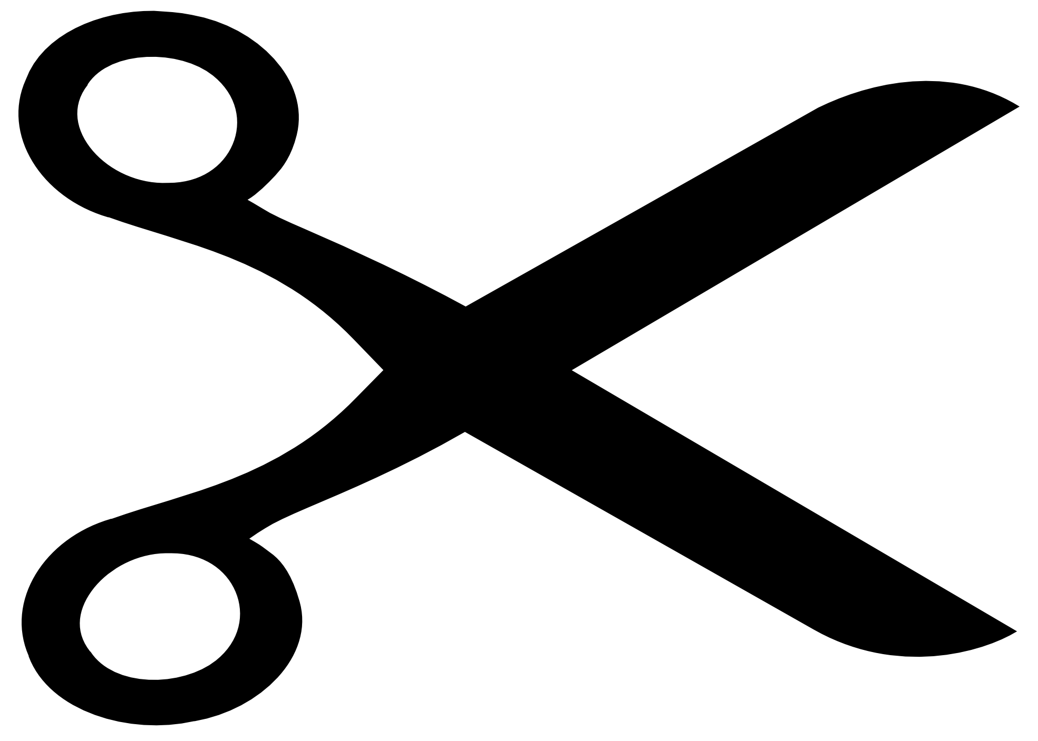
------------------------------------------------------------------------------------------------------------------------------------------

Max Aitken Academy Yearbook – ORDER FORM

Student name (first & last): _______________________________________________________
Homeroom Teacher: _______________________________________ Grade: ______________
I have enclosed the payment of $25.00 to purchase the 2020-2021 Max Aitken Academy Yearbook.

Parent Signature: __________________________________ Date: _______________________

