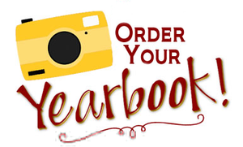
February 17, 2022
MEMO: MAA Yearbook 2021-2022

Dear parent/guardian:
If you would like to purchase a 2021-2022 Max Aitken Academy yearbook, please fill out the form below and return to your child’s homeroom teacher by Friday, April 1st.
The cost of the yearbook is $25.00 (payable by cash or cheque made out to Max Aitken Academy). Yearbooks must be purchased in advance.
Thank you for your support!
Max Aitken Yearbook Committee

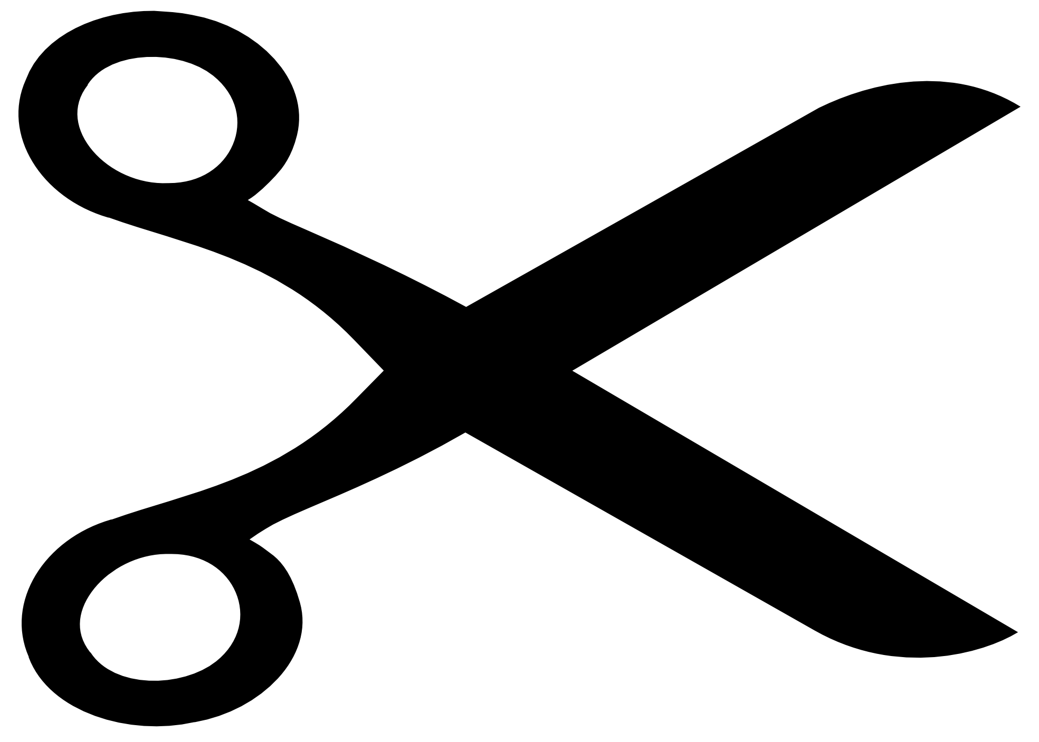
------------------------------------------------------------------------------------------------------------------------------------------

2021-22 Max Aitken Academy Yearbook

Student name (first & last): __________________________________________
Teacher: ____________________________________ Grade: ______________
$25.00 to purchase the 2021-22 Max Aitken Yearbook is enclosed.

Parent Signature: ______________________________ Date: _______________

