Week 3- Resources
Literacy-
Une phrase-(sentence)
https://safeshare.tv/my/safeviews/ss5e9e1554c4f3e/play
You can do a little booklet by using strips of paper and staple the pages together. Write your sentences/story and draw a picture. Be creative!
*see attachment for mots fréquents-(sight words)
Le cycle de l’eau-(water cycle)
https://www.youtube.com/watch?v=f21PUtM5YCU
Math-
Diagramme à bandes-(graph) https://safeshare.tv/my/safeviews/ss5e9e16f122204/play
You can access https://www.tumblemath.com for books and https://zorbitsmath.com/ for French activities that will be helpful for Math concepts.
Jour de la Terre/Earth Day-April 22
Recyclage-(recycling)
https://www.youtube.com/watch?v=GoaNHXx5o5g&list=PLUOoJ9BAgVnzA9tb8jq490G5ftiK620Ak
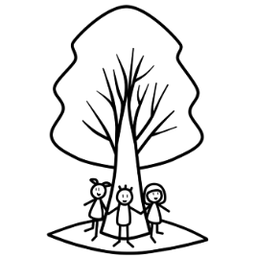

Enjoy your week full of adventures!

