Week 10- Resources
Literacy- Vocabulaire de l’été
https://safeshare.tv/my/safeviews/ss5eda62b98b70f/play
La plage https://safeshare.tv/my/safeviews/ss5eda62039b97c/play
Chanson-En été https://www.youtube.com/watch?v=t90VCzo4RW0
Livre-La Mer https://www.ednet.ns.ca/ensemblecheznous/informatif/la_mer/index.html

Math

Activities-Ways to Use a Hundred Chart
https://thestemlaboratory.com/15-brilliant-ways-use-hundred-chart/
Number chart-https://www.woojr.com/printable-number-charts/hundreds-chart/

Challenge Activity- Making Quick Sand https://www.youtube.com/watch?v=lxJlY8sATas
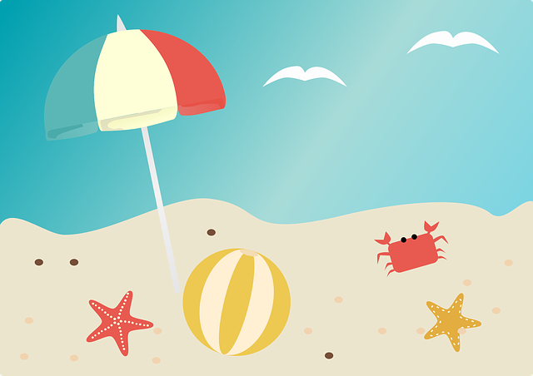
Enjoy your summer!

