Week 9- Resources
Literacy- Song- La météo https://safeshare.tv/my/safeviews/uiaq0LCF26Y/play
Book- Un drôle de piquenique https://www.ednet.ns.ca/ensemblecheznous/narratif/un_drole_de_piquenique/index.html
Math-
Video-L’heure(time) https://safeshare.tv/my/safeviews/ss5ed1a19a9952e/play

Challenge Activities
Art activity-Recycled Paper cloud craft https://reachinghappy.com/learning/recycled-paper-cloud-craft/
Science Experiment-Shaving cream rain https://www.youtube.com/watch?v=82BS_uSY4v8
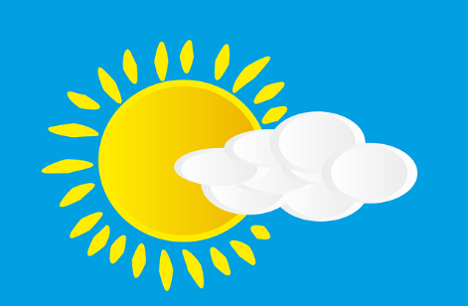
Have fun with the activities!

