Week 5- Resources
Literacy-
Activity- A poem that your child can read to you or Grandma. 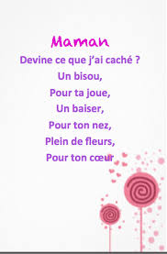
Bonne Fête des Mères!
See attachment for the French vocabulary to help write a card, poem or a coupon book.
Math- Activity to practice subtractions.
https://2nd-grade-math-salamanders.s3-us-west-1.amazonaws.com/Games-2nd/Subtraction-Games/subtraction-cover-up.pdf
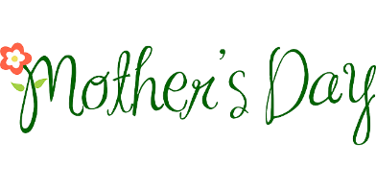

Enjoy your family

