Week 6- Resources
Literacy-
Activity- If you would like to print theses in order to practice the sight words or use them for the hopscotch activity.

Math- Video
Les formes géométriques-
https://safeshare.tv/my/safeviews/y64NQfhE7fs/play
* see attachment for vocabulary (les solides)
Challenge Activity – We practiced this addition strategy in class and your child can try it.
Make a 10 to add- https://safeshare.tv/my/safeviews/ss5eb1bc6deeae4/play

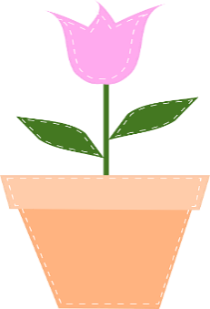

I am enjoying my tulips this week!

