|  |  |  |
| --- | --- | --- |
| **READING**  See the source image | **Reading Websites:** (Read/listen to books and retell the story to someone at home)   * [Dreamscape (playdreamscape.com)](https://go.playdreamscape.com/) **I’m excited! I’ve**   **made Usernames and Passwords for you all. I will e-mail your parents so you can start having fun reading.**   * Tumble Book Library: Username: nblib Password: nbschools * <https://www.tumblebooklibrary.com/> * Story Line Online Library: <https://storylineonline.net>   **\*Keep a log of books listened to or read to share when we return.** |   **30 MINUTES** |
| **LITERACY - 30 MINUTES A DAY** | | |
| **WORD WORK**  See the source image | **Spelling list**:  Word Work Suggestions:   * Spelling**:** Begin studying Unit 7 words. (See below) * Activities for weekly Spelling list   Rainbow write your Spelling words  Use each of your Spelling words in a sentence  Write Spelling words with a pen, pencil, marker  Try writing your spelling words with your opposite hand. |   **10 - 15 MINUTES** |
| **WRITING**  See related image detail | **Writing Suggestions:**   * Letter Writing - write a letter to your teacher and email it if you can. ([amy.anderson-mckay @nbed.nb.ca](mailto:lisa.lynch@nbed.nb.ca)) * Writing – Writing ideas to choose from this week. (See below)   **\*Remember keep all writing to bring back to school.** |   **10 - 15 MINUTES** |
| **MATH- 30 MINUTES A DAY** | | |
| **MATH**  See the source image | **Math Suggestions**   * **Dreambox** (15-20 min)   [https://play.dreambox.com/login/knjs/urus](https://can01.safelinks.protection.outlook.com/?url=https%3A%2F%2Fplay.dreambox.com%2Flogin%2Fknjs%2Furus&data=04%7C01%7Camy.anderson-mckay%40nbed.nb.ca%7C180704d760dc4c7bc04308d99d577d4a%7C4d2b5fdfc4d24911870968cc2f465c9f%7C0%7C0%7C637713821344962435%7CUnknown%7CTWFpbGZsb3d8eyJWIjoiMC4wLjAwMDAiLCJQIjoiV2luMzIiLCJBTiI6Ik1haWwiLCJXVCI6Mn0%3D%7C1000&sdata=5R%2FvjY5ewd75w2nxg8AqY%2FRGrI6YEfpZh73%2B2kK1rAA%3D&reserved=0)   * Worksheet: Focus is on place value (see below)   **\*Answers can be written on paper should you not have a printer**. |   **30 MINUTES** |
| See the source image | **All evidence of student work in Literacy and Numeracy should be returned to school with your child when school resumes.**   * Keep a folder of all the work. * Log daily reading. * Keep a writing journal. * Take pictures of at home learning. (Building, doing a puzzle, measuring for cooking, or reading to a younger sibling.) |  |



**Reading for Week 2 Home Learning**

[Dreamscape (playdreamscape.com)](https://go.playdreamscape.com/)

Dreamscape combines strategy, engagement, and imaginative reading passages to create

a fun, curriculum-aligned literacy game for grades 2 to 8….and it’s free.

I will email/text parents with usernames and passwords so you can begin having fun.

Let me know what you think. Can’t wait to use this additional learning tool in the classroom.



**Writing Ideas for Week 2 Home Learning**

|  |  |  |
| --- | --- | --- |
| I am most proud of _______ because… | What are some of your chores at home? Do you like chores? Explain why. | What is your favorite holiday? Explain why. |
| If you could have any pet at all, what would you choose? Explain why. | If you drew a flag to represent yourself, what would it look like? | What is the best season of the year? Why is it the best? |
| Tell me your favorite part about school? Use as much detail as you can. | List all the things that make you unique. | If you could be a superhero, choose 2 superpowers you like to have. |

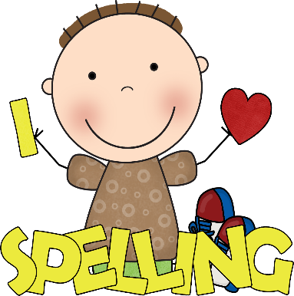

**Spelling Words Unit 7**

**Long e (ee)**

feet looks asleep

books queen teeth

first games street

every ago about



**Math for Week 2 Home Learning**

