Instructions for logging into Teams

Using the website:
-Go to office.com
-login using student email and password (format for email: studentusername.nbss.nbed.nb.ca. Example for Veronica Beek may be: VERBEE12345@nbed.nbss.nb.ca)
-Typically on the left side of the screen there will be icons. Click on the icon for “Teams”

If using the app:
-Just login using student email and password!
Once on Teams, Click on the class you want to look at!
Example:
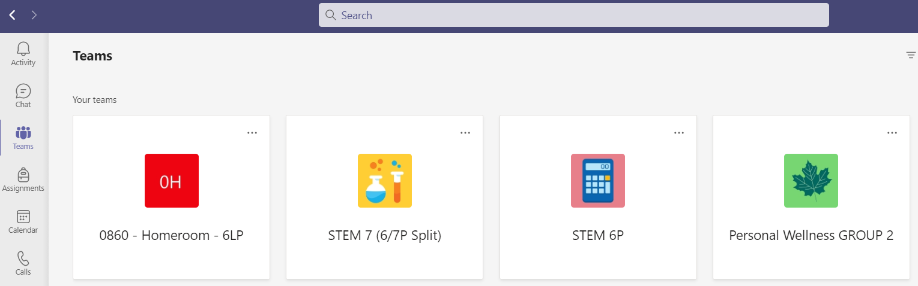

-Teams has a chat function that students can use to contact me:
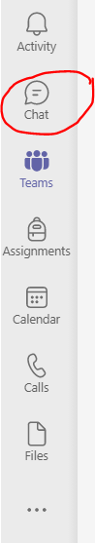

-Students can access their virtual meetings by using the calendar in Teams. The booked meeting will show up there and they just click on it to join.
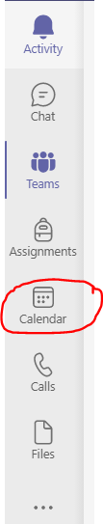

Email me if you have any issues! Veronica.beek@nbed.nb.ca

