MAA Ring In Spring Spirit Week
Tuesday April 19th- Friday April 22th, 2022.
Please submit to Ms. Richardson by noon on April 22th, 2022.
Grade/Teacher’s Name: _________________
Activity | Tally
Tuesday April 19th: Wear Spring Colors Day (pastels, blue, yellow, purple, pink etc…) | Number of students participating ____________  Number of students present ____________
Wednesday April 20th: Wear your favorite Spring hat. | Number of students participating ____________  Number of students present ____________
Thursday April 21st: Wear something with flowers…. Be as creative as you like. | Number of students participating ____________  Number of students present ____________
Friday April 22nd: Socks & Sandals or Rubber Boots and Socks. Wear your funkiest/ favorite socks.  This is also EARTH DAY | Number of students participating ____________  Number of students present ____________
Challenges or activities for the month of April:
- Grades K-8: Conduct a cleanup of the school grounds and Forest Classroom. (April 22nd is Earth Day).
- Watch the Lorax with your students and have a discussion activity on why trees are so important.
- Grades: 3-8: Trace your teacher on banner paper or bristle board and decorate their outline as an earth day superhero, then use it as part of your door decoration for the door decorating contest. They must have at least one superpower and a superhero name of you wanted they could also have a cool slogan. Doors will be judged on Monday April 26th and Tuesday April 27th throughout the days. Your door will be judged on creativity, originality, colorfulness, brightness, logo, and their superpower.
- Trace a circle on a piece of paper and color the inside of the circle as if it were the world. On a different piece of paper, trace the student's hands and glue them to the back of the world. Then, make a heart, and color it red. Lastly, glue the heart onto the world.
- https://www.simpleeverydaymom.com/earth-day-printable-headband/
- https://nontoygifts.com/3d-earth-craft-kids-earth-day-craft/
- https://www.messylittlemonster.com/2018/04/earth-day-black-glue-craft-kids.html

- 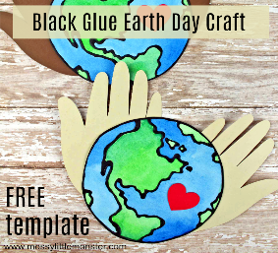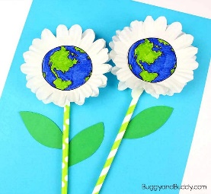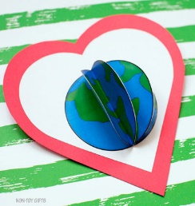
- K-2: Coloring contest: You can find pictures attached to print and have your student’s color. Have them place their name on the back with their class. Judging will take place between April 26th- 29th. Please place in Ms. Richardson’s mailbox by April 22nd.

- 3-8: Earth Day drawing contest:
1. Must be students originally work.
2. Need to have a theme or title
3. Must be colored (pencil crayons, markers, or crayons) student choice.
4. Must be completed on white paper (letter size).
5. See below for examples: https://www.google.com/search?rlz=1C1GCEV_enCA952CA952&sxsrf=APq-WBsCtQTeVoK-7sxD3Ew_uj7v_d11BQ:1649784094664&q=earth+day+drawing+contest&tbm=isch&chips=q:earth+day+drawing+contest,online_chips:poster+contest:DBN5tIjCnsM%3D&usg=AI4_-kT3E8d6uJ-9MFhG-3VksMLguuGEEg&sa=X&ved=2ahUKEwiWrKzXhI_3AhX-lIkEHTIhDyYQgIoDKAB6BAgEEAo&biw=1366&bih=657&dpr=1
- Judging will take place between April 26th- 29th. Please place in Ms. Richardson’s mailbox by April 22nd.

